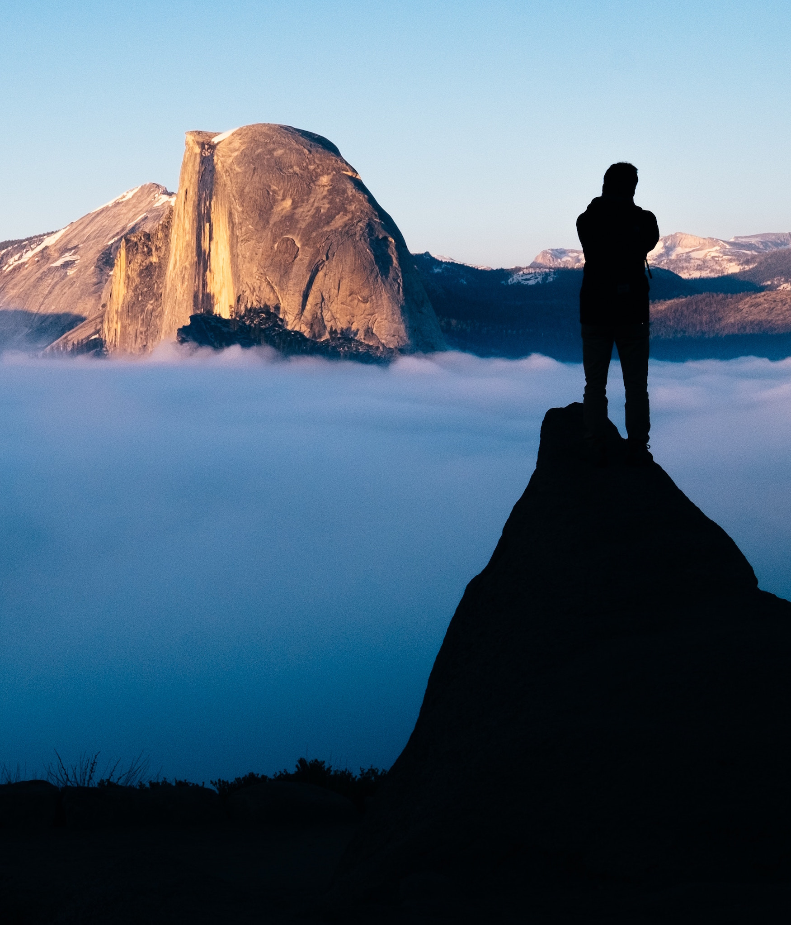

**Source is fictional**

Travel Books

Author’s name

Title

Paula Martinez

to Yosemite

The Hiker’s Guide